

**CHATTER**

**Software Requirement Specification**

– Hanoi, MAY 2022–

**Table of Contents**

I. Overview 3

1. Introduction 3

2. System Functions 4

3. Common Requirements 5

II. Functional Requirements 6

1 .Sign in, Sign up functional requirement 6

2. Home page functional requirements 9

3. Menu page functional requirements 11

4. Contact us page functional requirements 14

# I. Overview

## 1. Introduction

The Chatter app is an food ordering and delivery platform that allows customers to read the menu, place order, and rate the restaurants online. What sets Chatter apart from other food delivery applications is we also create a community for customers to share their experiences, connect with others by our chatting feature.



## 2. System Functions

#### a. Screen Flow

*[This part shows the system screens and the relationship among screens. You can draw the Screens Flow for the system in the form of diagram as below]*



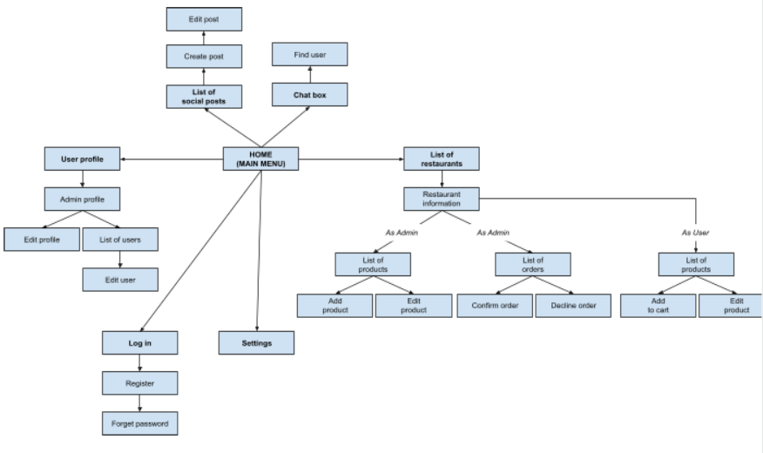

#### b. Screen Details

*[Provide the descriptions for the screens in the Screens Flow above]*

| **#** | **Feature** | **Screen** | **Description** |
| --- | --- | --- | --- |
| 1 | See all restaurant | Home | Main menu |
| 2 | Setting | Setting | Change web setting, theme |
| 3 | Login | Login | login |
| 4 | Edit Profile | User Profile | edit profile, manage users |
| 5 | See social posts | List of social post | View users’s post |
| 6 | Chatting | Chat box | chat with friends on the platform, chat with restaurant, create groups |
| 7 | View all restaurants | List of restaurants | Display a list of all restaurants |
| 8 | View products | List of products | Display products from chosen restaurant |
| 9 | Add product | Add product | Admin can add/ delete product |
| 10 | Edit product | Edit product | Admin can edit price or information of that product |
| 11 | View order | List of order | Admin can view all the orders |
| 12 | View products | List of product | User can see all the products |
| 13 | Cart | Add to cart | View cart |

#### c. User Authorization

*[Provide the system roles authorization to the system features (down to screens, and event to the screen activities if applicable) in the table form as below – replace Role1, Role2,… with the specific system user role names]*

| **Screen** | **Role1** | **Role2** | **Role3** |
| --- | --- | --- | --- |
| Home | x | x | x |
| Setting | x | x |  |
| Log in | x | x |  |
| User profile | x | x |  |
| List of post | x | x | x |
| Chat box | x | x |  |
| List of restaurants | x | x | x |
| List of products | x | x | x |
| Add product | x |  |  |
| Edit product | x |  |  |
| List of order | x | x |  |
| Cart | x | x |  |
|  |  |  |  |

In which:

* Role1: Administrator
* Role2: Registered User
* Role3: Unregistered Guest

#### d. Non-Screen Functions

*[Provide the descriptions for the non-screen system functions, i.e batch/cron job, service, API, etc.]*

| **#** | **Feature** | **System Function** | **Description** |
| --- | --- | --- | --- |
| 1 | Servlet | java servlet | Backend is written in java servlet |
| 2 | Database | Sql server | Microsoft sql server |

## 3. Common Requirements

*<<fill here with all the common requirements...>>*

# II. Functional Requirements

## 1. Sign in, Sign up functional requirement

| **Requirement ID** | **Requirement Statement** | **Comment** |
| --- | --- | --- |
| FR001 | The “sign in” page shall have 2 edit text for member to enter their email and password. | If member types in wrong email or password, a warning will be popped up |
| FR002 | Member shall be able to tick on the “remember me” check box to keep their email and password in the text field next time they access. |  |
| FR003 | Member shall be able to get they password back by click on “forgot password?”. | Password will be sent to member’s email |
| FR004 | Button “sign in” to go to home page. |  |
| FR005 | New members shall be able to sign up by clicking “sign up” below the “sign in” button. |  |
| FR006 | The “sign up” page shall have “first name”, “last name”, “email” and “password” text field for new members to fill |  |
| FR007 | Button “sign up” to create new account for members | Button “sign up” is disable until members fill all the text field and click on the check box “agree with term and policy” |

## 

## 

## 

## 

## 2. Home page functional requirements

| **Requirement ID** | **Requirement Statement** | **Comment** |
| --- | --- | --- |
| FR001 | The “homepage” shall have 3 small tabs: Dessert, Main Menu and Drinks. | Just for fast order. No search bar |
| FR002 | The “homepage” shall have a search bar which can use to find friends or groups. |  |
| FR003 | Member shall be able to post status, picture or file in “posting section” |  |
| FR004 | Member shall be able to like, dislike, comment or share others posting |  |
| FR005 | Member shall be able to check their message in the “message” icon on the top right of the website |  |
| FR006 | Member shall be able to fast message a friend by clicking into friend’s avatar on the right side of the website | Just for fast message |
| FR007 | Member shall be able to check notification in the bell icon “notification” on the top right of the website |  |

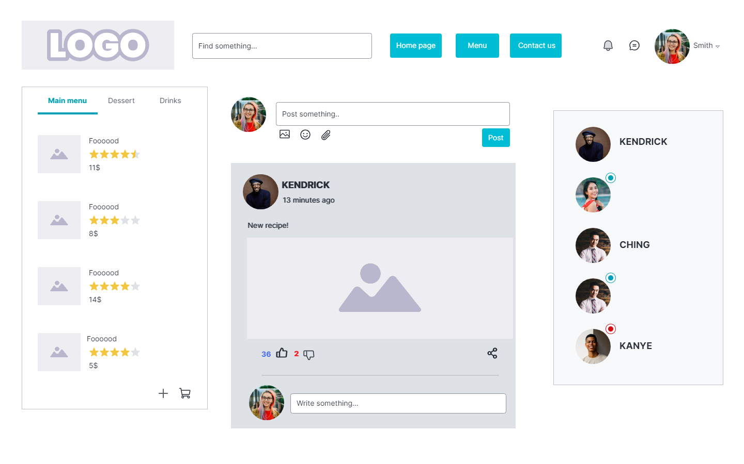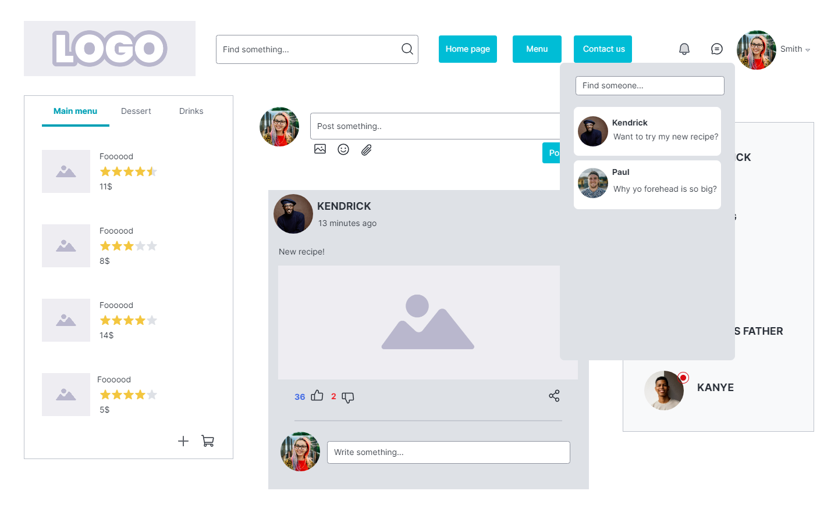

## 

## 3.Menu page functional requirements

| **Requirement ID** | **Requirement Statement** | **Comment** |
| --- | --- | --- |
| FR001 | “Menu” page shall have 3 tabs: “Main menu”, “Desserts”, “Drinks”. |  |
| FR002 | Each (food) item in the list shall have name, description, vote by others and price |  |
| FR003 | Members shall be able to add item to cart by the “+” button | One each click |
| FR004 | Members shall be able to choose the price range by the check box on the left side of the website |  |
| FR005 | Members shall be able to choose the brand by the dropdown list “brand” |  |
| FR006 | Members shall be able to check the popular and top-buy-today foods by click on button “Most popular” and “Today’s Deals” | The list will refresh and filter all looking for-item |
| FR007 | Members shall be able to pay the order by clicking into the “cart” button on the top left | Member can delete item by the “-“ button in cart |

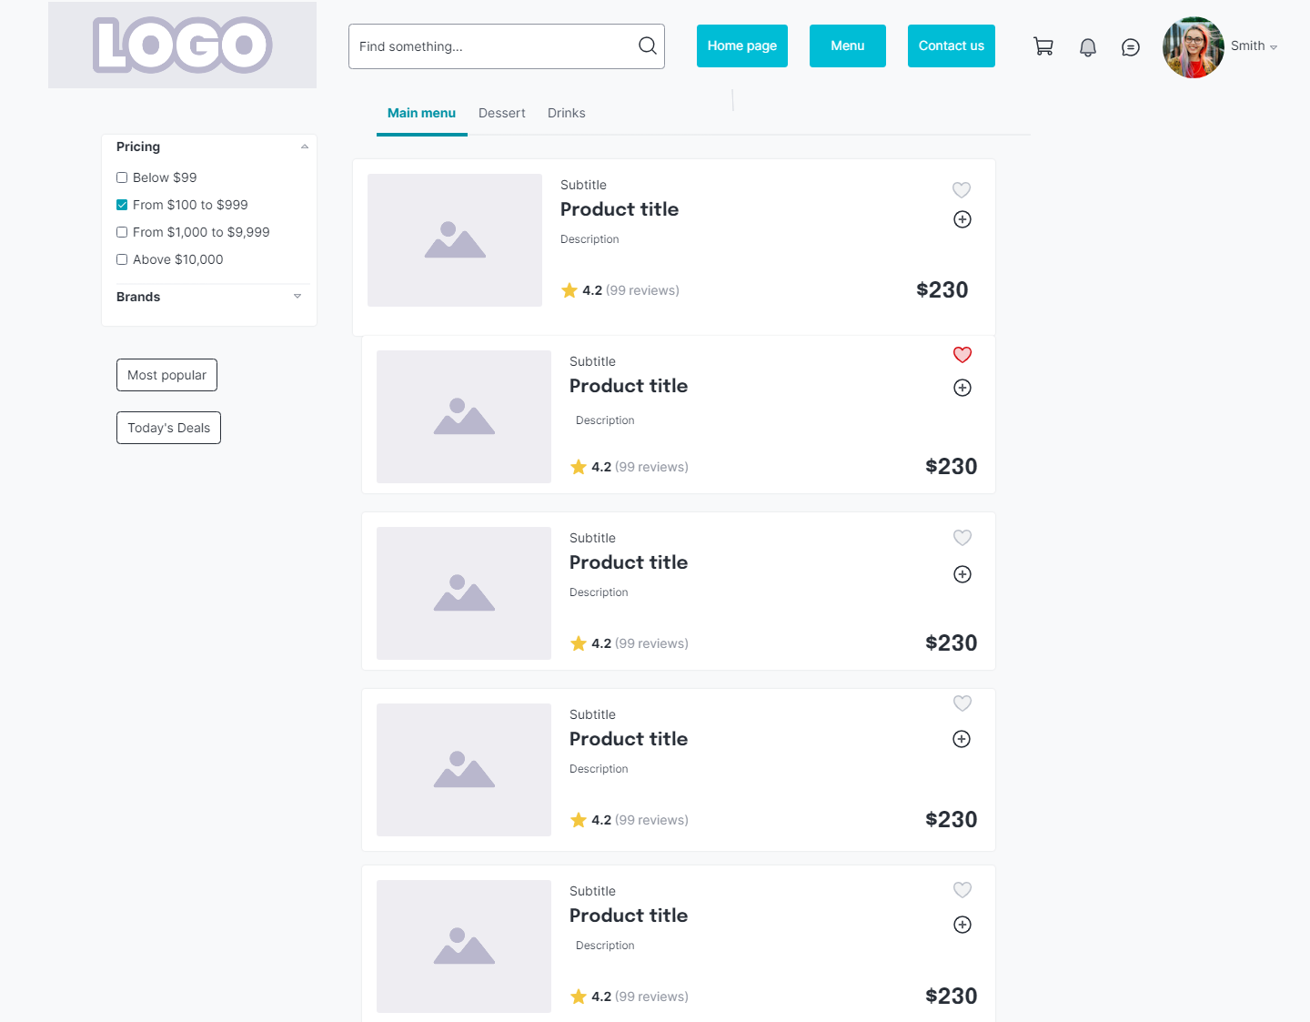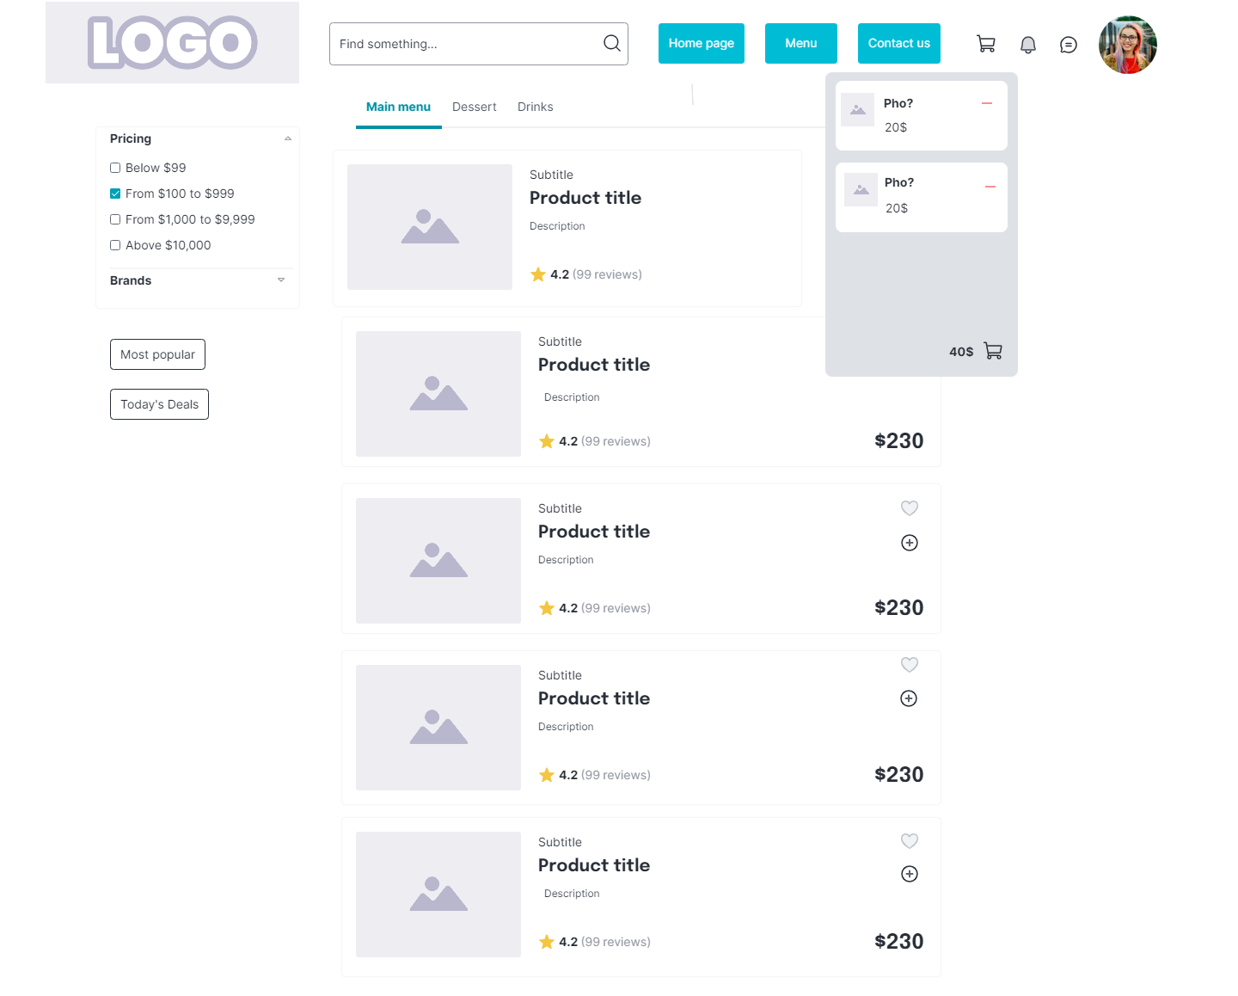

**4. Contact us page functional requirements**

| **Requirement ID** | **Requirement Statement** | **Comment** |
| --- | --- | --- |
| FR001 | “Contact us” page shall have 5 text fields for member to fill: “First name”, “Last name”, “Email”, “Phone numbers” and “your share” |  |
| FR002 | Members shall be able to send message to us by clicking into “submit” button |  |
| FR003 | Members shall be able to receive news from us by clicking into button “Subscribe”. | The news will be sent to member’s email |

